Floral Symphony
Glenbard South & Glenbard West Music
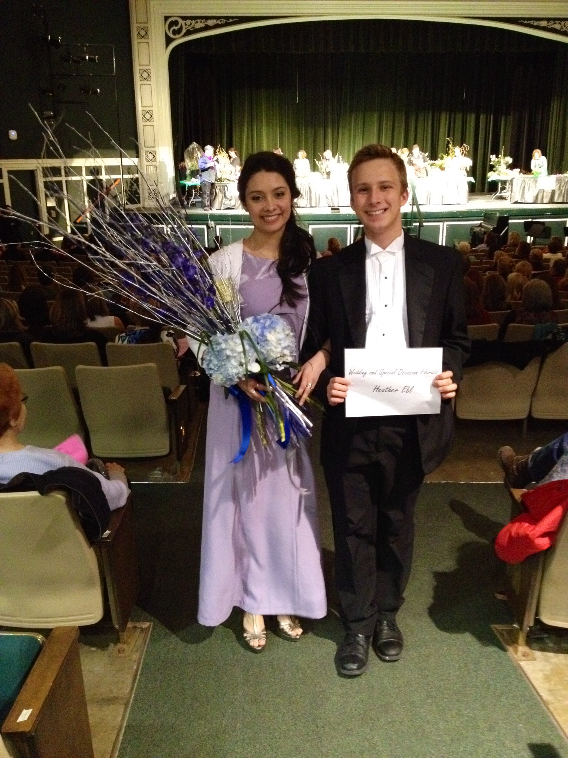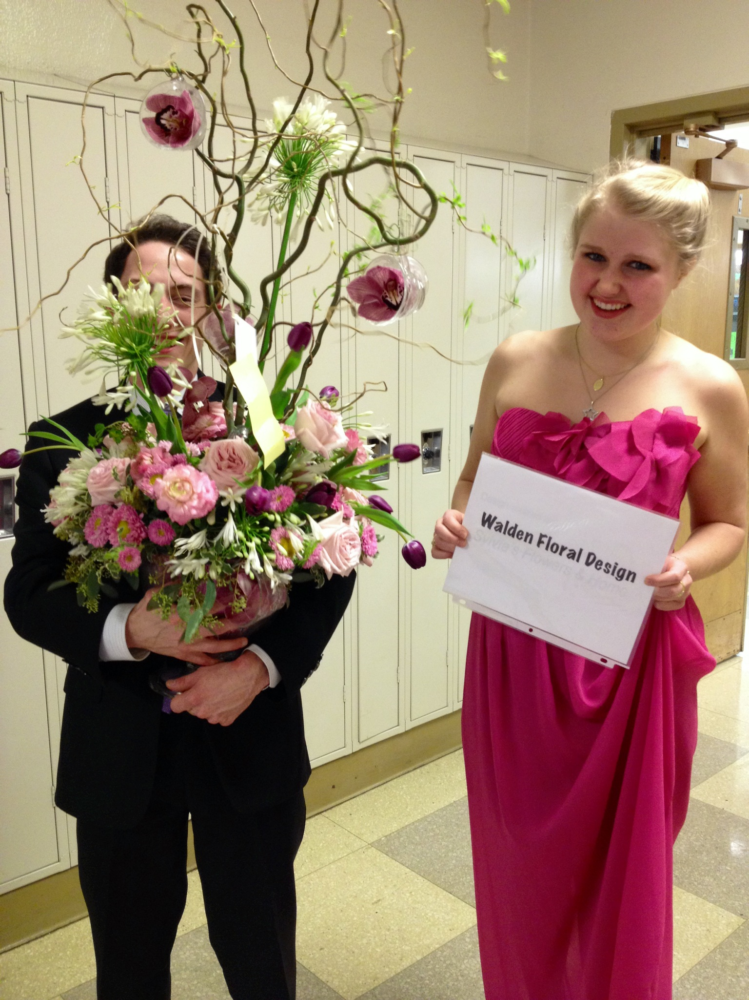

What is a Floral Symphony? It is a flower show, set to music, with a twist. Local florists (Heather Ebl, The Green Branch, Walden Floral Design, and Stylish Events) create exceptional arrangements while Master of Ceremony, Daniel Stober, entertains and describes the dazzling designs.

It's a fun night for a great cause - the Glenbard South and Glenbard West music programs. All arrangements will be raffled off that evening to lucky attendees.

When: March 3, 2015
Time: 7:00-9:30 pm
Where: Glenbard South Auditorium
Questions: Contact Lora at lkhardt@aol.com

